EMPLOYEE ATTRITION ANALYSIS- POWERBI – EDA

PROBLEM STATEMENT:

End to end project of analysing the employee attrition rate and as an HR analyst.

Here, we will be uncovering some deep insights as to why employees are leaving so soon.

**Employee attrition** is the gradual reduction in the company's Workforce due to Employees leaving voluntary or involuntary it is often measured as a rate and can be assigned from resignations terminations retirements or even layoffs

Employee attrition KPIs-

1. total employee count,
2. employee churn rate,
3. average employee rating,
4. departmental distribution and more.

This metrics are necessary in understanding workforce dynamics and organizational health.

HR analysis dashboard, data visualization and business intelligence skills.

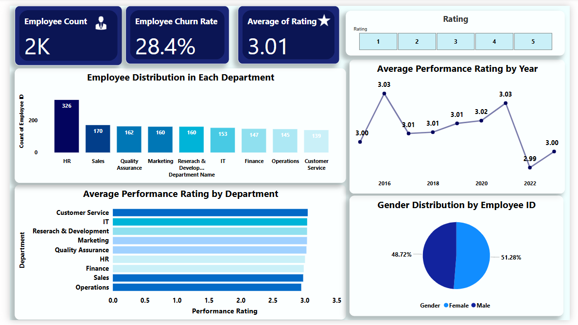

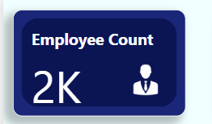**Employee Count (2K)**  
→ Total number of employees analyzed in the dataset.

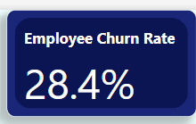 **Employee Churn rate 28.4%**→ overall employee CH rate is 28% which basically means that 28% of the employees have left the company

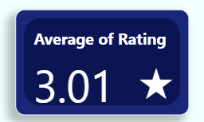**Average of Rating (3.01)**  
→ Overall average performance rating across all employees.

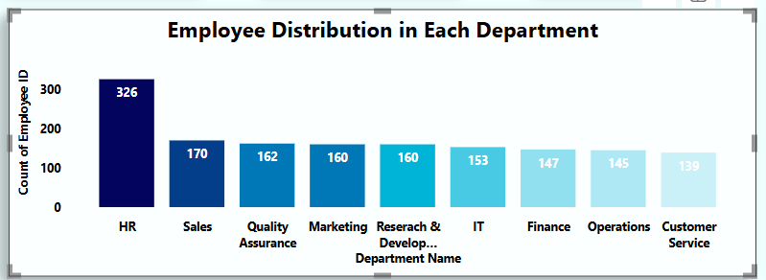 **Employee Distribution in Each Department**

* **Type**: Horizontal bar chart
* **Insight**: HR has the highest employee count (326), followed by Sales, QA, and others.
* **Use**: Shows how employees are spread across departments.

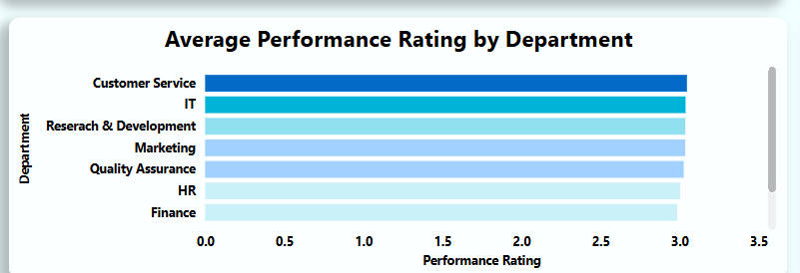 **Average Performance Rating by Department**

* **Type: Horizontal bar chart**
* **Insight: Customer Service and IT have the highest average performance ratings, Finance the lowest.**
* **Use: Compares departmental performance quality.**

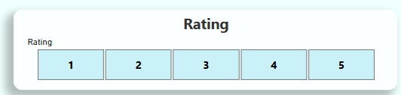**Rating Slicer (1 to 5)**  
→ Allows filtering of the dashboard based on selected performance rating values.

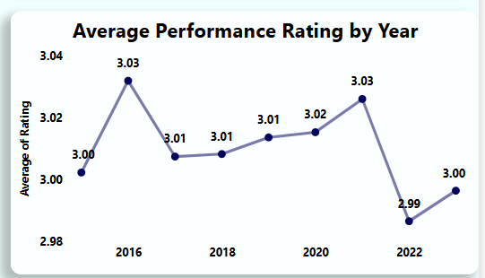  
**Average Performance Rating by Year**

* **Type**: Line chart
* **Insight**: Rating peaked in 2016 (3.04) and 2021 (3.03), dropped slightly in 2023 (3.00).
* **Use**: Identifies performance trends over time.

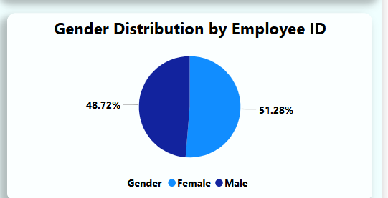  
**Gender Distribution by Employee ID**

* **Type**: Pie chart
* **Insight**: Male (51.28%) slightly outnumber female employees (48.72%).
* **Use**: Shows workforce gender diversity.

Page2-

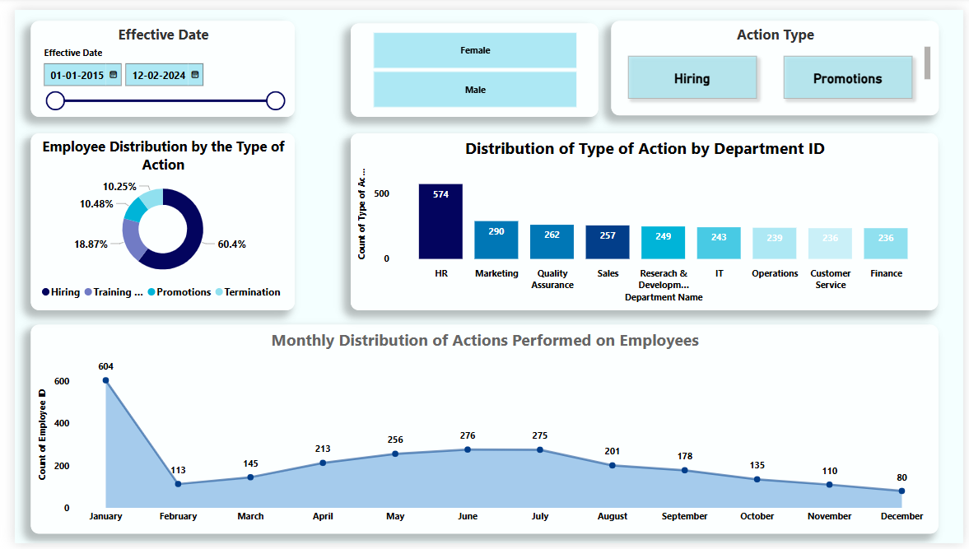  
Each visual in this dashboard focuses on **HR activity insights** — when and where hiring, promotions, training, and terminations occurred, broken down by **department**, **gender**, and **time**.

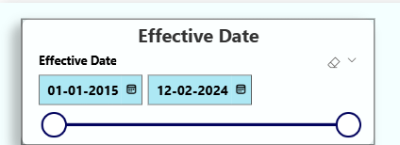 **Effective Date (01-01-2015 to 12-02-2024)**  
→ Date range filter to view employee actions within a selected time frame that were performed.

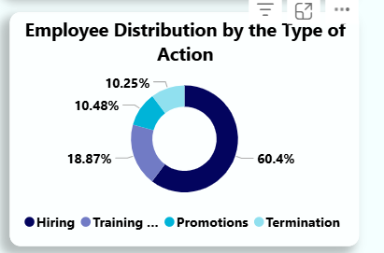 **Employee Distribution by the Type of Action (Donut Chart)**

* **Insight**:
  + **Hiring**: 60.4% of total actions
  + **Promotions**: 18.87%
  + **Training**: 10.48%
  + **Termination**: 10.25%
* **Use**: Shows the proportion of each action type performed on employees.

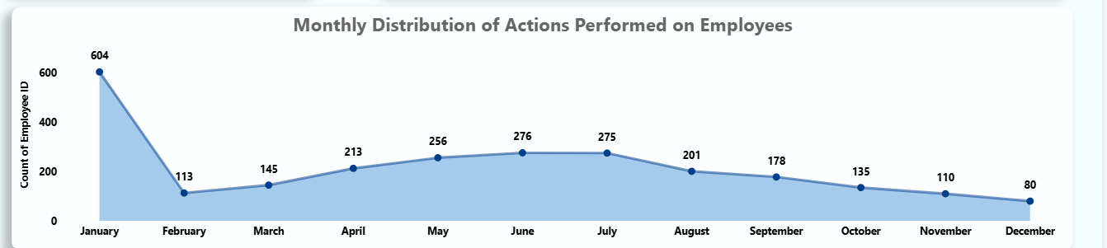  
**Monthly Distribution of Actions Performed on Employees (Line Chart)**

* + **Insight**:
    - Peak in **January** (604 actions)
    - Lowest in **December** (80 actions)
    - Gradual decline from July onward
  + **Use**: Tracks how employee actions vary by month across the year.

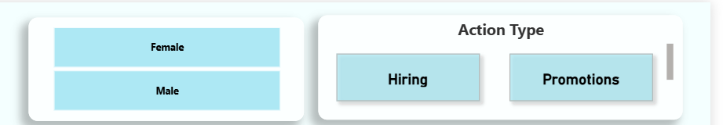  
**Gender Filter (Female / Male)**  
→ Filter to view data by gender.  
**Action Type Filter (Hiring / Promotions)**  
→ Allows selection of specific employee action types for analysis (e.g., Hiring, Promotions).

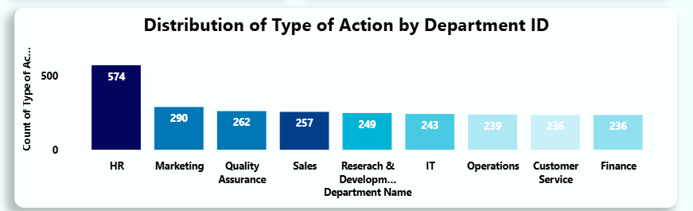  
**Distribution of Type of Action by Department ID (Bar Chart)**

* **Insight**:
  + **HR** department had the most actions (574), followed by Marketing, Quality Assurance, etc.
* **Use**: Identifies which departments had the most HR actions like hiring, promotion, etc.